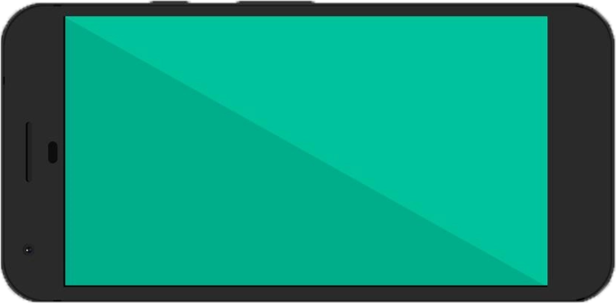

UNITY SPLASHSCREEN

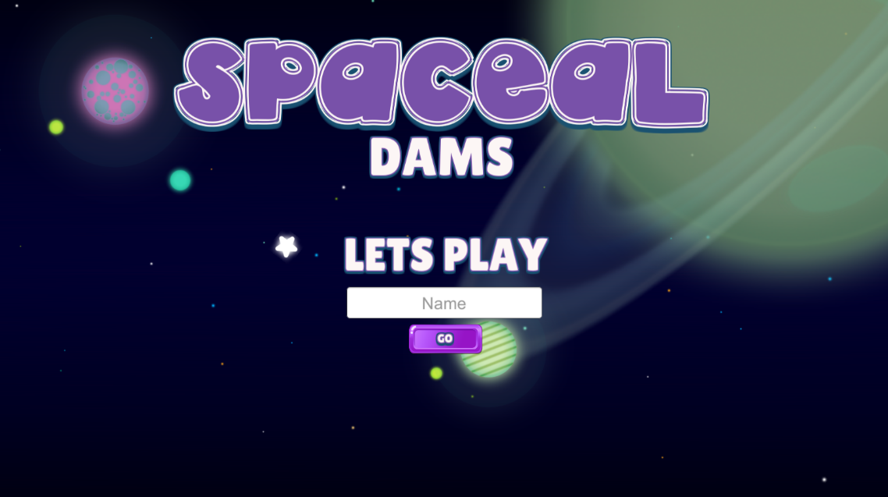

LANDING

* This will appear when the app is newly installed to android phone or detect that player list is empty

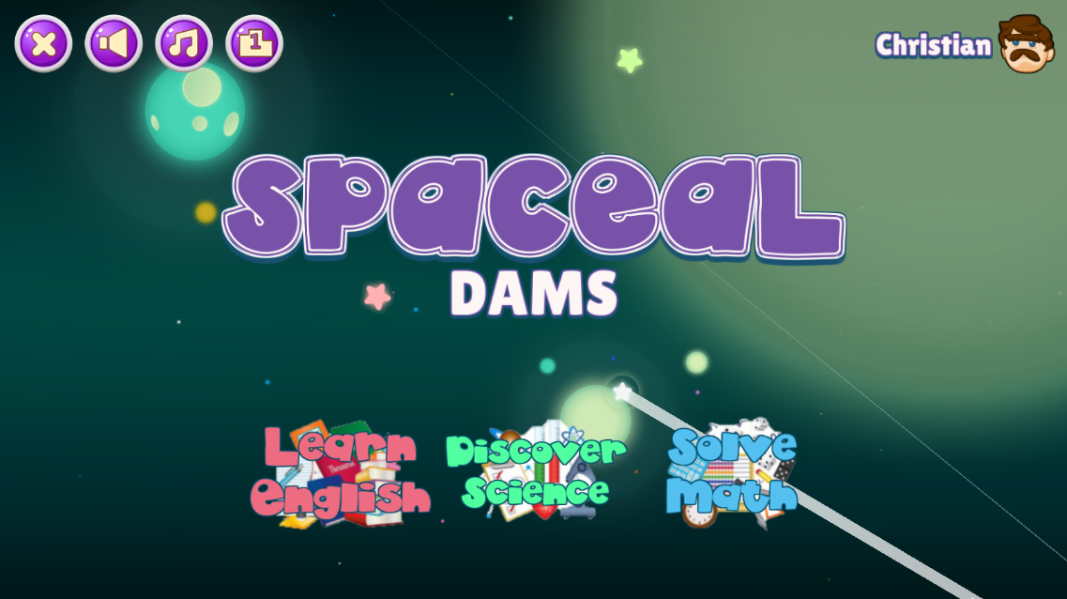

Updated HOME

* Show name of current player and icon
* Icon have animation to know the player that it’s clickable

s



PLAYER LIST

* If the player taps the player icon in home this will appear
* Can add new player
* Can select current players
* The scrollbar will automatically show

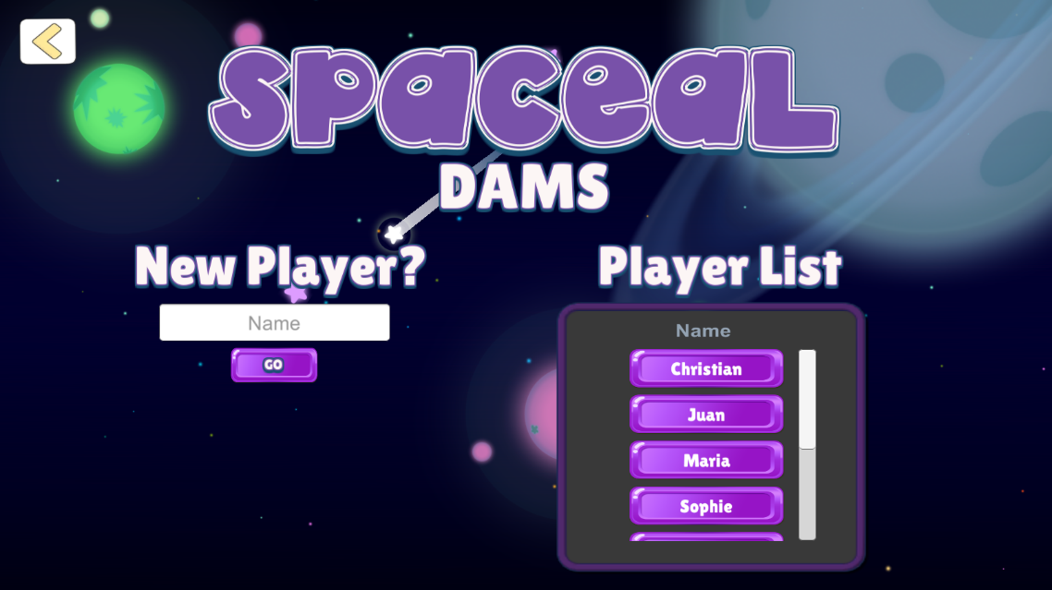



LEADERBOARD

* Show icon gold, silver, bronze for the top 3 players
* The scrollbar will automatically show

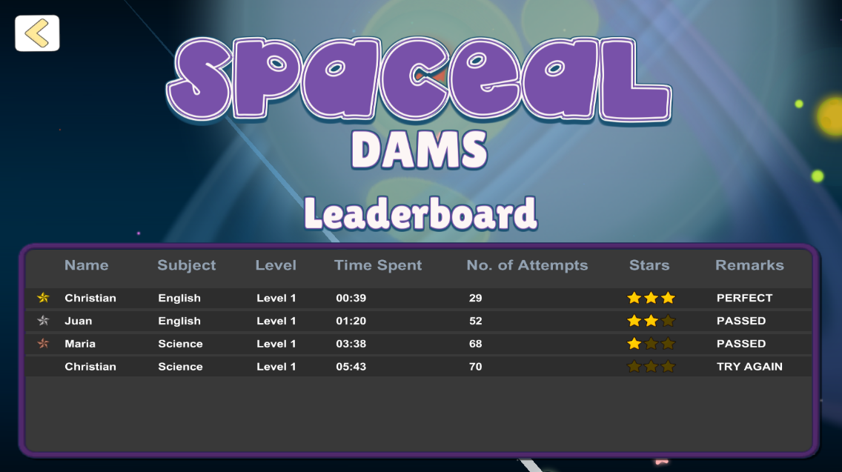

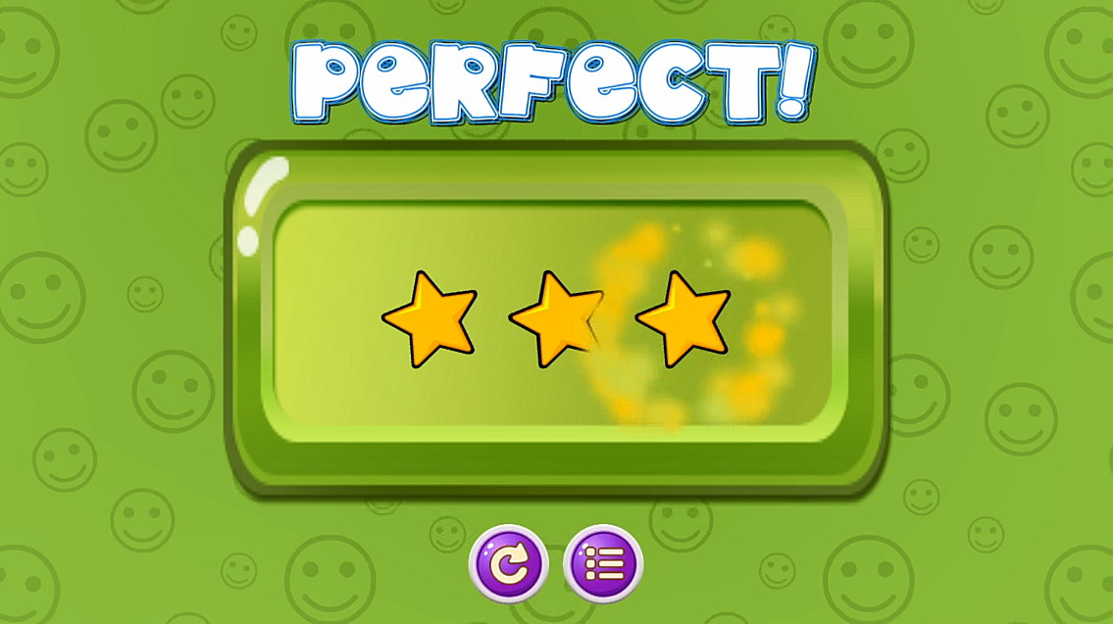

SCORING

* Have animation on stars